**Automatic Skull Segmentation and Classification on CT images**

Segmentation is a labor intensive operation and fundamental for many medical image analysis projects to understand the contents and context. The aim of this project is to segment the skulls out of sample brain CT images. The following is an example manual skull segmentation.



**Data Set:** <https://drive.google.com/open?id=1yOfQu6BZWVo_MKcVUBpM45JGPmNNuE3X>

There are 60 high resolution CT scans in the folder (segxxx). In each seg folder, there are two files; CT.mhd and CT.zraw:

CT.mhd – image header file

CT.zraw – compressed CT pixel data.

You can read this CT file using many medical image processing programs and libraries, one of which is ITK (www.itk.org).

**Skull segmentation**:

Use any technique or algorithm you like to segment skull. In this project, the skull is defined as the rigid bone region around brain. A segmentation object is a binary image with 1’s and 0’s. An example segmentation is in the data set “seg1” folder. To view the sample segmentation, download Seg3D2 and open the project file “{data_root}\seg1\seg1.seg3dproj\seg1.s3d” in Seg3D2. It should look like something like below.

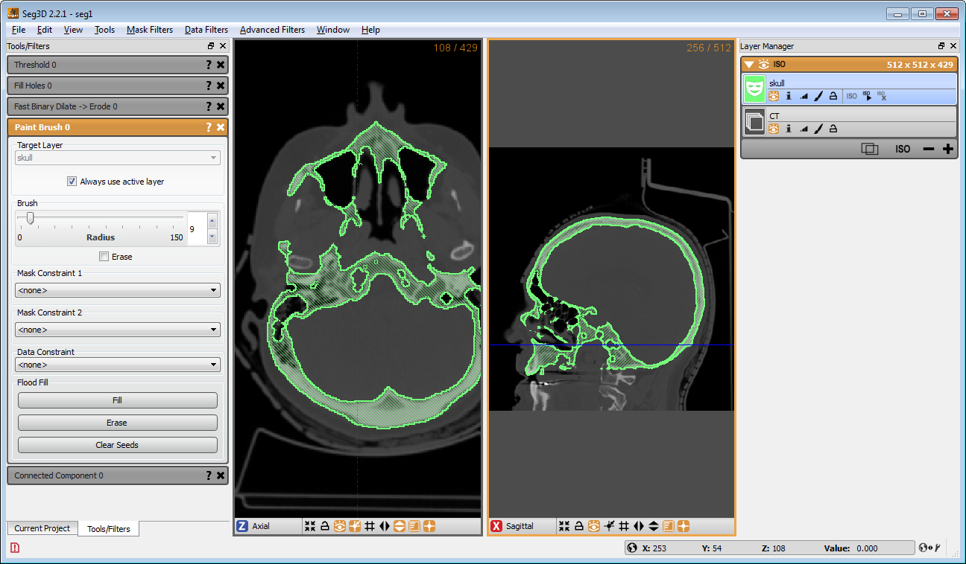

**Requirement**:

The segmentation process must be fully automatic.

Mentor:

Jinkoo Kim (Jinkoo.Kim@stonybrookmedicine.edu)